Routing & Navigation

# The Basics

## <base href>

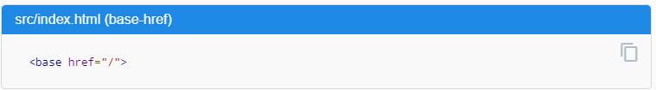

## Router imports

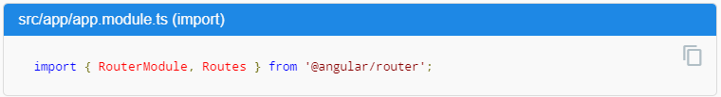

## Configuration

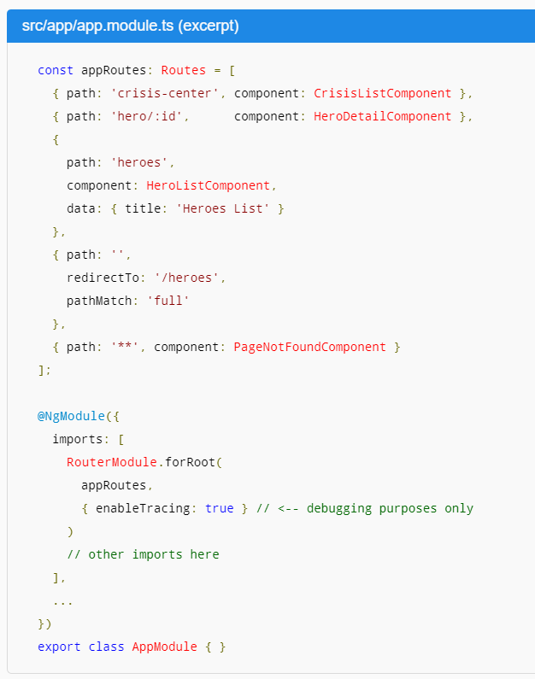

## Router outlet

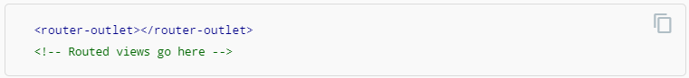

## Router links

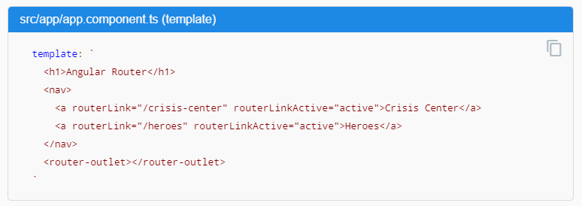

## Router state

## Activated route

## Router events

## Summary